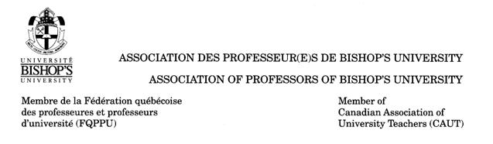
APPLICATION FOR MEMBERSHIP

NAME: _______________________________________________________________________________
ADDRESS: ____________________ ____________________ _____________________________
Number Street City

JOB TITLE: ________________________________Department: ____________________ PT/FT: _______

EMAIL: Work: ______________________________ Alternate (off campus): _________ ____________
PHONE: Work: _________________ Home: ____________________ Cell: ________________________
(optional)

I, the undersigned, freely and voluntarily hereby apply for membership in the Association of Professors of Bishop’s University. I pledge my honor to faithfully observe the Constitution and laws of this Association, to promote its interests and further its principles.

I hereby authorize the Association of Professor of Bishop’s University, its agents or representatives to act on my behalf as my exclusive representative in all matters concerning certification, incorporation and collective agreements.
I certify that I have paid this day personally the sum of two dollars ($2.00) as an initiation fee.

Signature of Applicant: _________________________________________________________________
Date: _________________________ Received by: _________________________________________

2600 College, Sherbrooke, Quebec, Canada J1M 1Z7 Tel.: (819) 822-9600

Office Only -- Membership Number:

